The following FRDC logos can have any colour applied to the background.

To change colour right mouse click, select “FORMAT PICTURE” and then choose ‘Fill’ and select the fill colour of your choice.

This option is also very handy when you need to add a logo to a PowerPoint presentation.

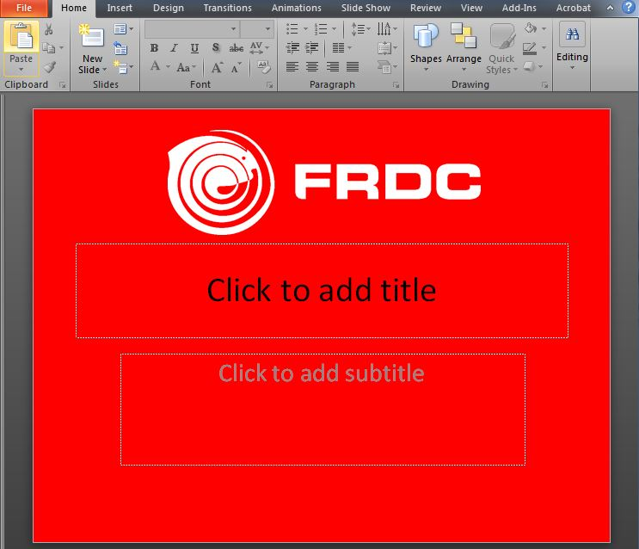

Various shades of blue applied in these examples

