How to submit a deliverable through FishNet:

Log in to FishNet, select “submit deliverable” button:

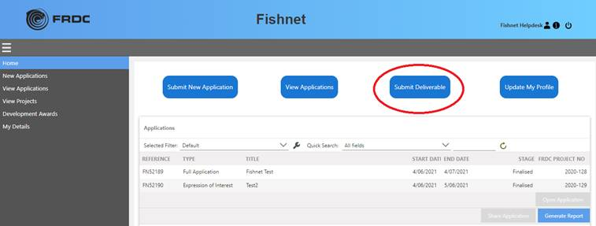

Once selected, a list of relevant deliverables will be made available for selection:

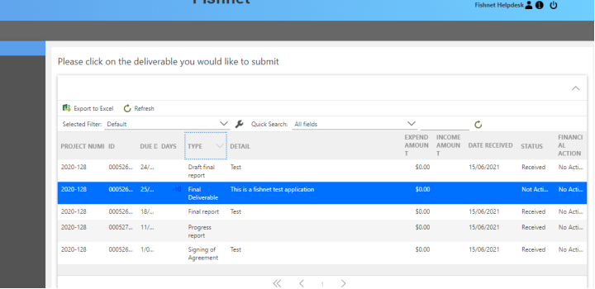

Click on the deliverable that is ready to submit and the submission page will open, note any deliverable marked as received cannot be opened:

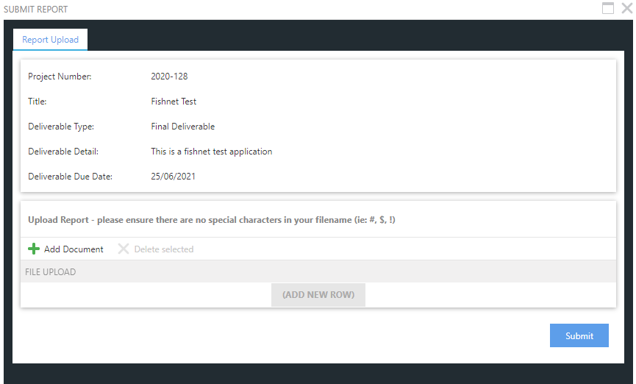

Select + add document to upload attachments. If more than one attachment is required select add new row. Select Submit button.

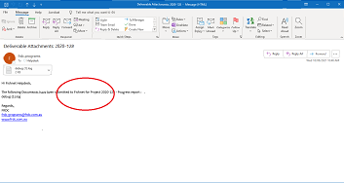

The Principle Investigator will receive an email that confirms the submission of the deliverable report.

Submission of a final report through FishNet:

Follow the steps above for submitting a deliverable report. There is an additional step when submitting the final report, the “final report check list” will open and requires completion.